**DAILY ONLINE ACTIVITIES SUMMARY**

|  |  |  |  |  |  |
| --- | --- | --- | --- | --- | --- |
| **Date:** | | **19/06/2020** | **Name:** | **JASLINE SHARON TAURO** | |
| **Sem & Sec** | | **4th sem, A Section** | **USN:** | **4AL18CS029** | |
| **Online Test Summary** | | | | | |
| **Subject** | **MICROCONTROLLER AND EMBEDDED SYSTEMS** | | | | |
| **Max. Marks** | **20** | | **Score** | **20** | |
| **Certification Course Summary** | | | | | |
| **Course** | | Application Developer | | | |
| **Certificate Provider** | | **AWS Educate** | **Duration** | | **3 hrs.** |
| **Coding Challenges** | | | | | |
| **Problem Statement:**   Write a C Program to Count total set bits in all numbers from 1 to n. | | | | | |
| **Status: EXECUTED** | | | | | |
| **Uploaded the report in GitHub** | | | **YES** | | |
| **If yes Repository name** | | | <https://github.com/jaslinesharontauro/C_Prgms> | | |
| **Uploaded the report in slack** | | | **YES** | | |

Online Test Details: (Attach the snapshot and briefly write the report for the same)

Certification Course Details: (Attach the snapshot and briefly write the report for the same)

Coding Challenges Details: (Attach the snapshot and briefly write the report for the same)

ONLINE TEST:

Today we had assessment on the subject “MICROCONTROLLER AND EMBEDDED SYSTEMS”. The test was based on Fourth module of this subject. The test was comprised of 20 questions of ONE mark each, out of which I scored 20.

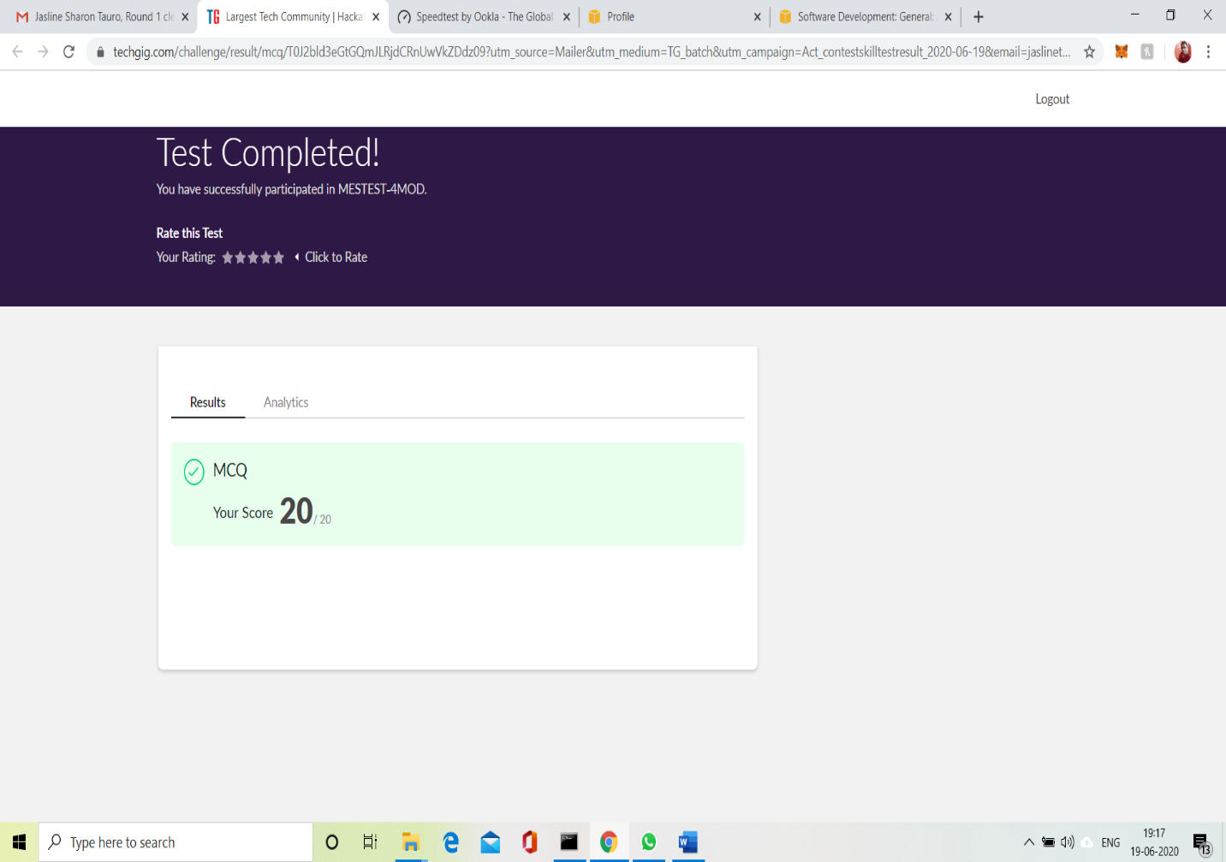

CERTIFICATION COURSE DETAILS:

Today I have continued the course “Application Developer” by AWS Educate. In this course today I learnt about the last chapter of Platforms module i.e. Platform visualization. And I have also completed the final assessment and final project of this course and I have earned a badge.



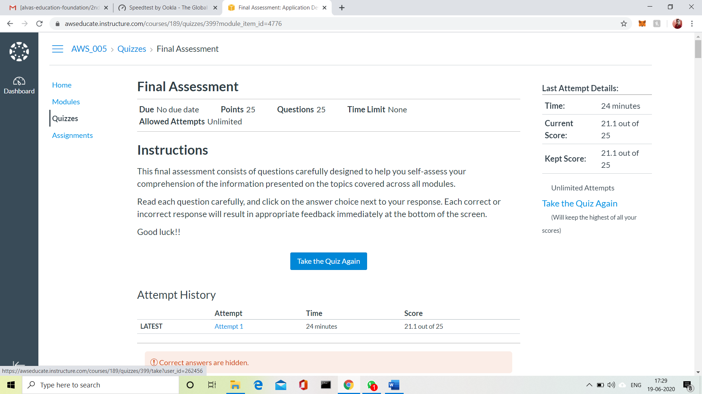

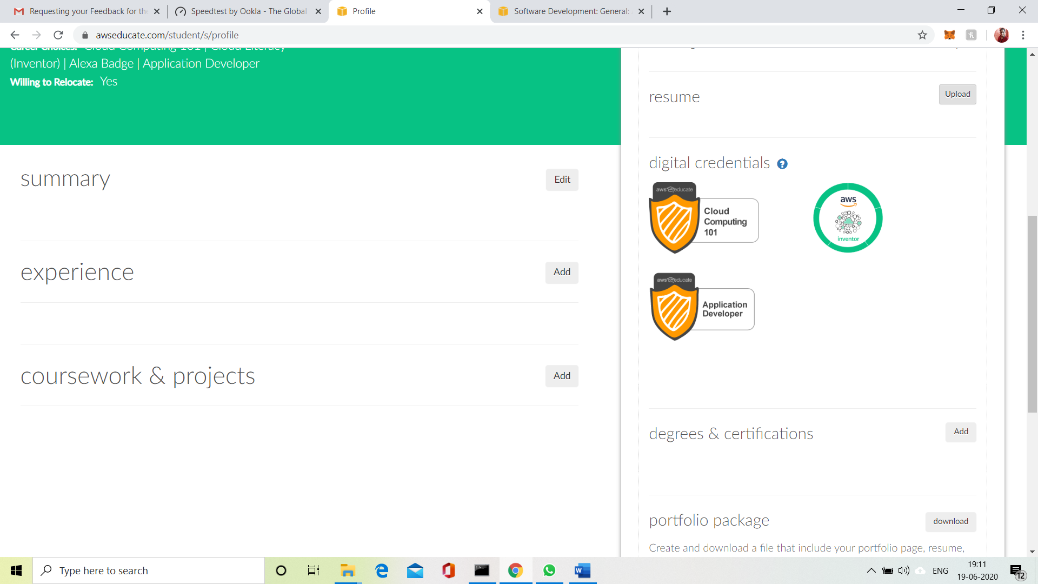

3.CODING CHALLENGES:

Problem Statement:

Write a C Program to Count total set bits in all numbers from 1 to n

Given a positive integer n, count the total number of set bits in binary representation of all numbers from 1 to n.

**Examples:**  
Input: n = 3  
Output: 4  
Input: n = 6  
Output: 9

**Hint:** Read a positive integer (example: 3 indicates range), so u have to consider 1, 2, 3 as the input convert these numbers into binary and count the number of 1 in that (1- 0001, 2- 0010, 3- 0011) number of 1s from all 3 digit is 4 so the answer is 4.

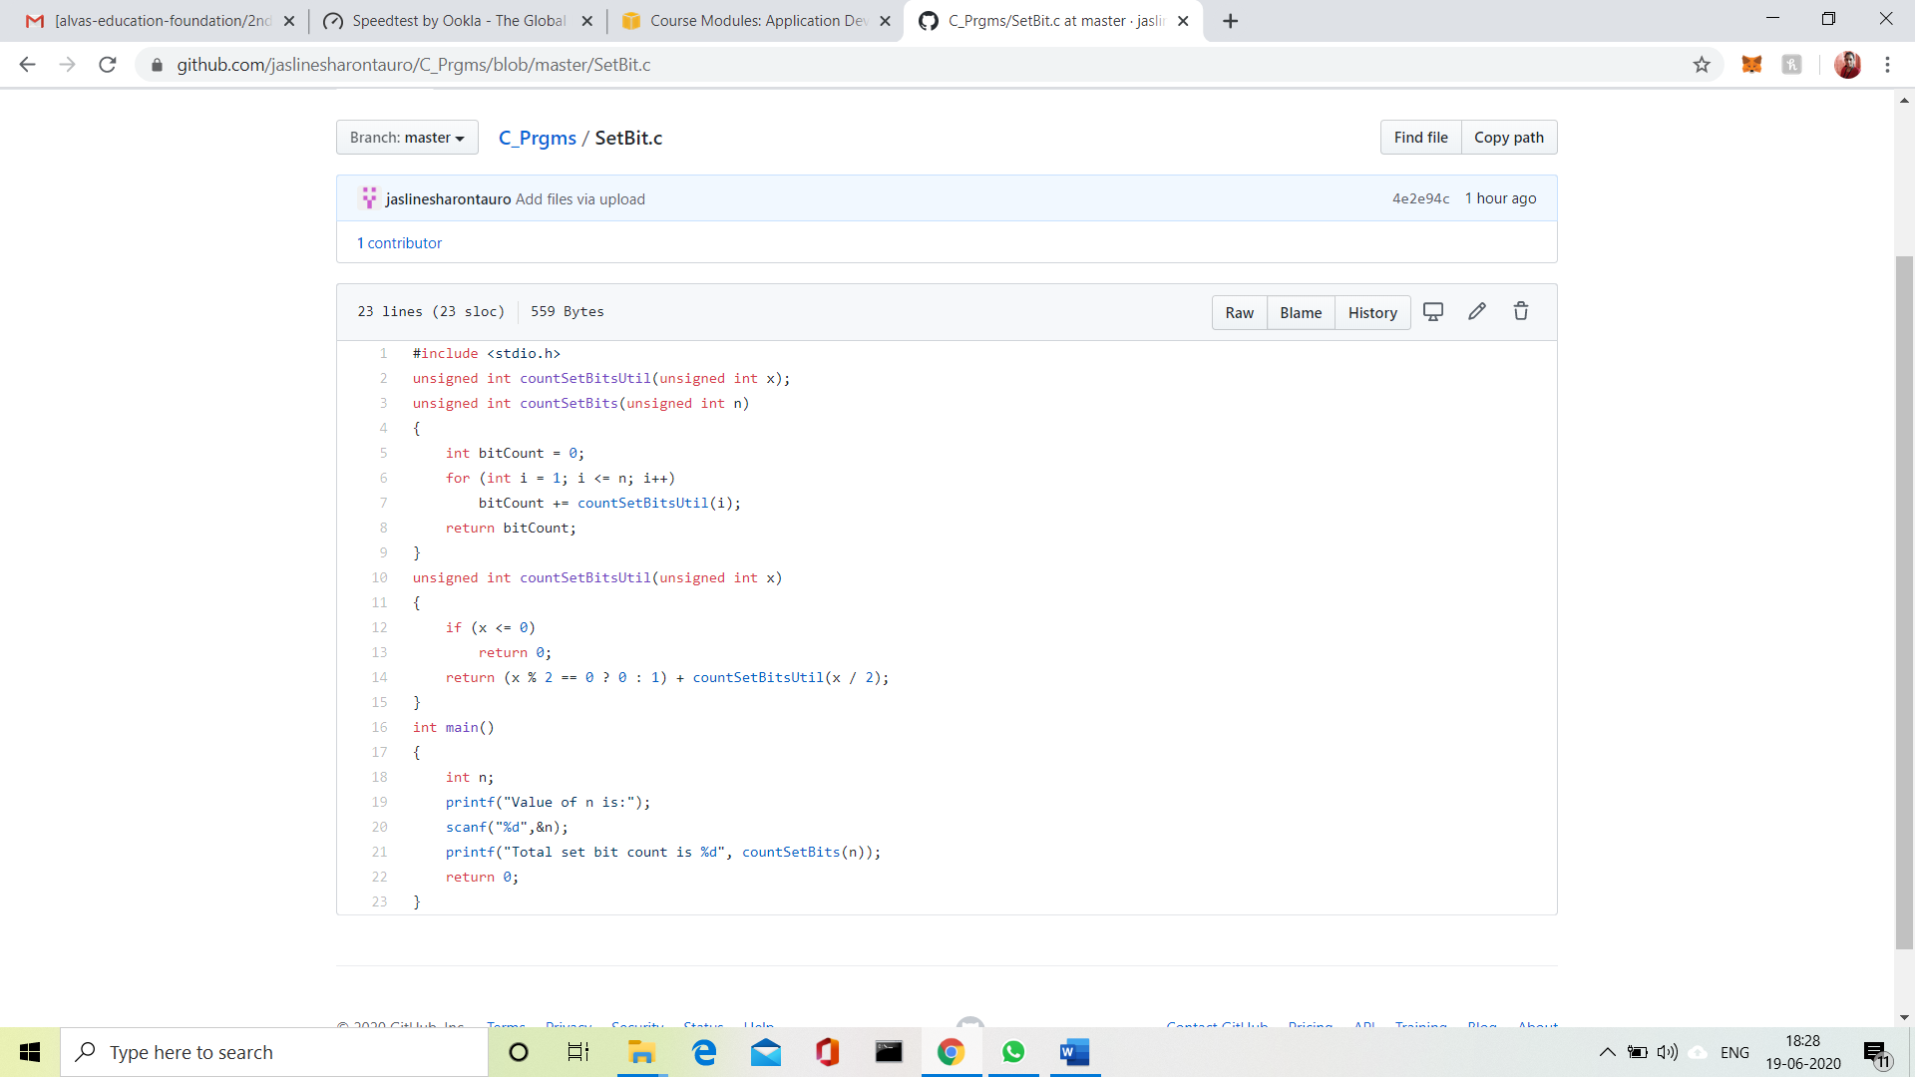

Solution uploaded in GitHub.